17.26: a) 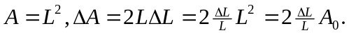 But 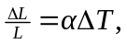and so 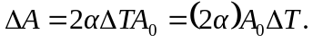
b)

